KingHonor Paper Products Co., Ltd. — Expert in Sustainable Packaging Solutions
KingHonor
Sustainable Packaging Solutions
Professional Manufacturer of Disposable Paper Cups, Bowls & Food Containers
Table of Contents
Company Profile
Core Strengths
Products & Custom Services
Sustainable Development Philosophy
Service Commitment
Contact Us
I. Company Profile
Founded in 2018, KingHonor Paper Products Co., Ltd. is a professional manufacturer specializing in disposable paper food packaging containers. Headquartered in Ho Chi Minh City, Vietnam, the company benefits from its unique geographical location, abundant eco-friendly raw material resources in Southeast Asia, and favorable policies under multilateral trade agreements such as the CPTPP, establishing core competitiveness for the global market.
Since its establishment, KingHonor has been committed to providing global customers with cost-effective, safe, compliant and green one-stop packaging solutions. Our products are widely used in catering, milk tea, fast food, supermarkets, retail and other fields. With stable quality and excellent service, we have won the wide trust and recognition of international customers.
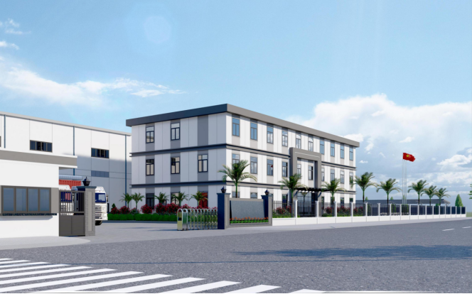
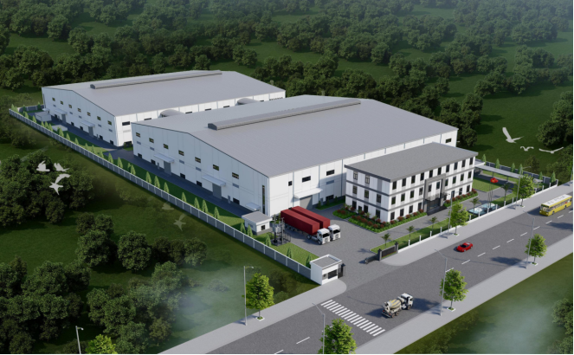
II. Core Strengths
1. Geographic & Cost Advantages
Strategic Location: Headquartered in Ho Chi Minh City, Vietnam, with a well-developed logistics network, efficiently covering the Asia-Pacific, Europe, America and global markets.
Resource Advantages: Access to high-quality and stable eco-friendly pulp raw materials nearby, effectively controlling supply chain costs.
Trade Convenience: Benefiting from free trade agreements such as CPTPP, we enjoy tariff reductions and trade facilitation in many countries, ensuring our products are highly price-competitive in the international market.
2. Professional Manufacturing Strength
With years of deep experience in disposable paper cups, paper bowls and food containers, we possess mature production technology and a strict quality control system.
Our products fully comply with international food contact safety standards (such as FDA, EU EC, etc.), ensuring safe and reliable use.
3. Customization Capability
We provide one-stop customization services covering size, shape, structural design, LOGO printing and material selection, precisely matching customers’ brand positioning and market demands.
III. Products & Custom Services
Core Product Series
1. Disposable Paper Cups
Suitable for coffee, milk tea, hot and cold beverages, and other scenarios. Available in a variety of sizes (3oz/7oz/9oz/12oz/16oz), with single-wall and double-wall insulated options.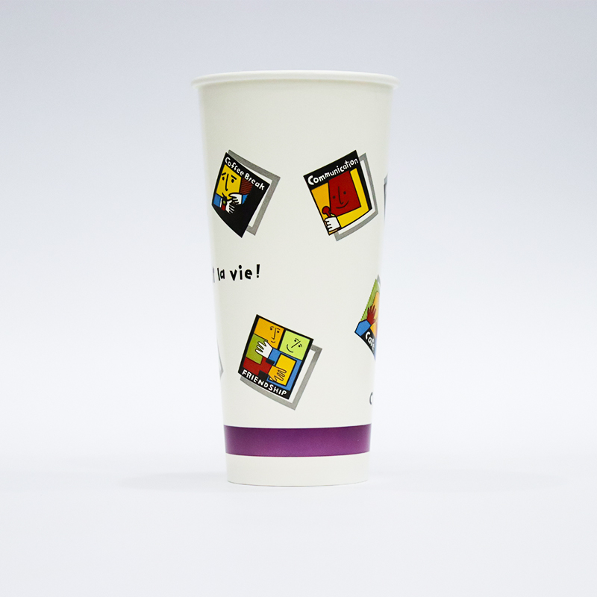
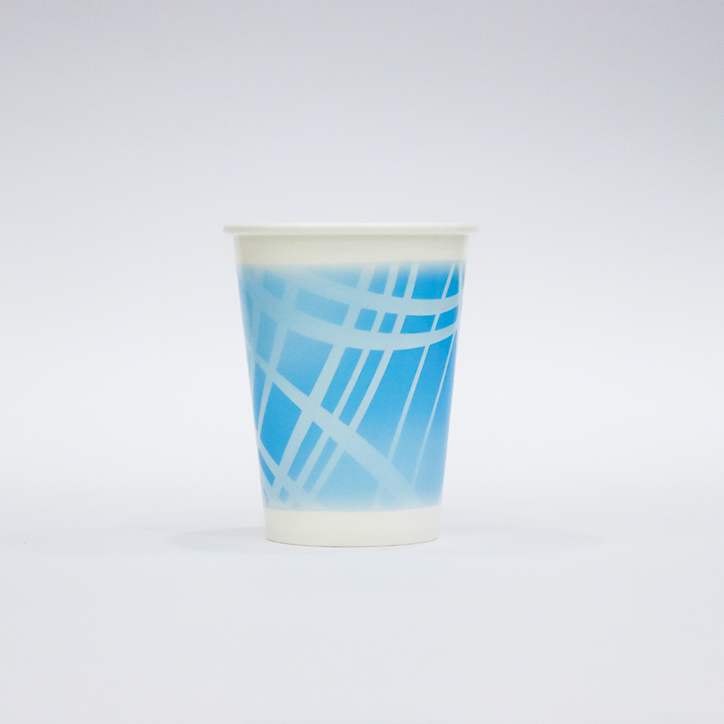
2. Disposable Paper Bowls
Specially designed for soups, noodles, porridge, salads, fast food and more. Oil-resistant, water-resistant, sturdy and durable, suitable for a wide range of catering applications.
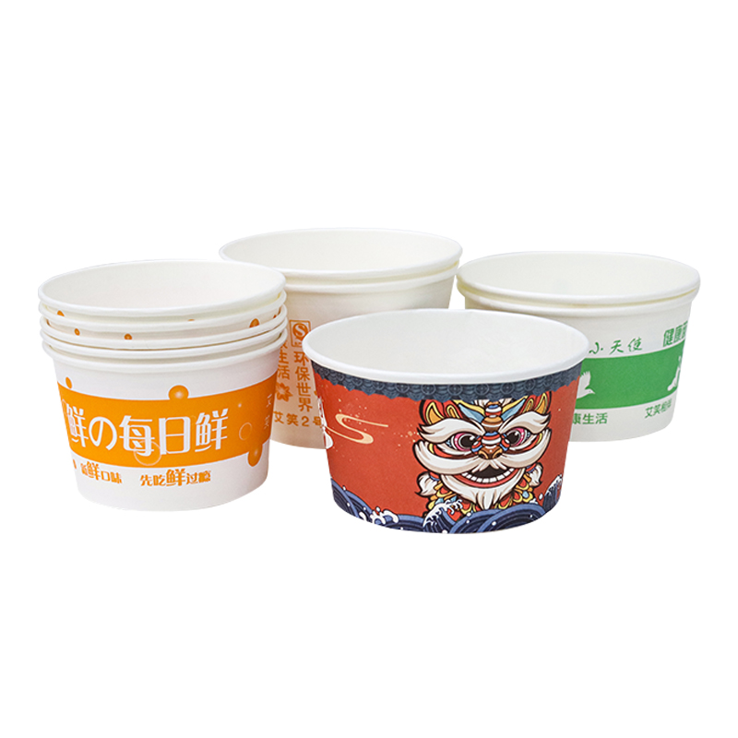3. Food Packaging Containers
Including various paper lunch boxes, takeaway containers, french fry cups, popcorn buckets and more, meeting diverse packaging needs for takeaway, fast food, snacks and other applications.
Full-Range Custom Services
Size Customization: Customized products with different capacities, diameters and heights according to customer requirements.
Design Customization: Support for single-color, multi-color, spot-color and UV printing to perfectly present brand logos and visual designs.
Material Customization: A variety of eco-friendly material options, such as food-grade base paper, biodegradable coatings, kraft paper and more.
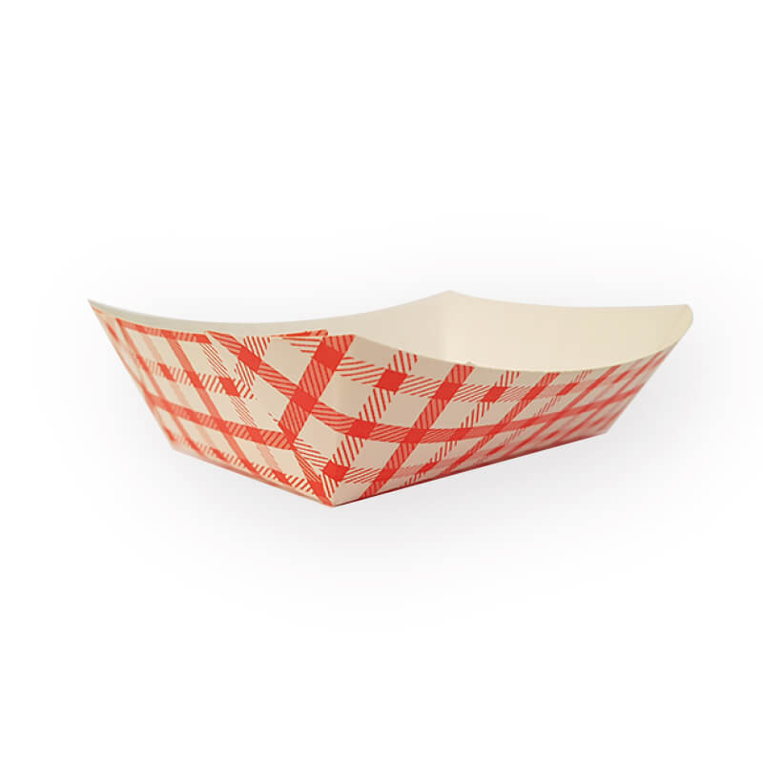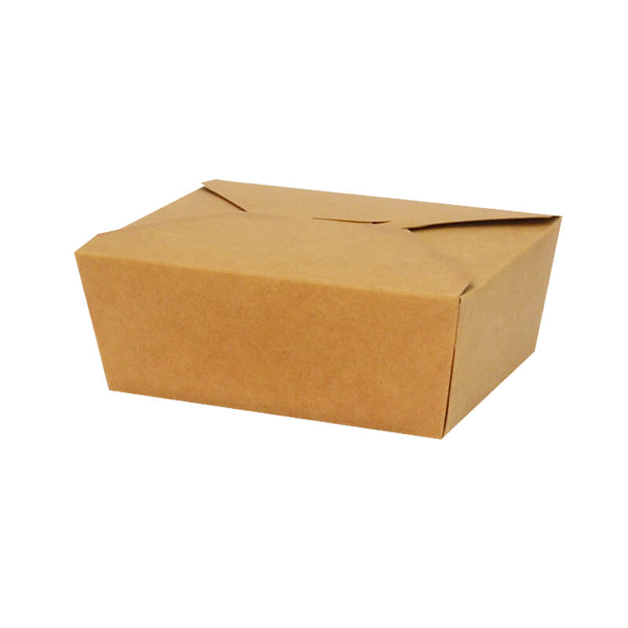
IV. Sustainable Development Philosophy
Against the global trend of environmental protection, KingHonor takes sustainable development as its core corporate strategy.
Eco-friendly Materials: We prioritize recyclable and biodegradable virgin wood pulp as well as food-grade eco-friendly coatings, minimizing environmental impact from the source.
Green Production: We implement clean production processes and strive to reduce energy consumption and waste discharge during manufacturing.
Paper Replacing Plastic: We support the global "plastic restriction and ban" initiative by providing customers with green packaging alternatives to plastic, jointly protecting the earth’s ecosystem.
V. Service Commitment
KingHonor adheres to a customer-centric approach and makes three solemn commitments:
Highly Competitive Pricing: Relying on our Vietnam-based production advantages and large-scale manufacturing, we provide customers with optimal cost-effective solutions.
On-Time & Reliable Delivery: Efficient production planning and logistics systems ensure orders are completed on schedule and with consistent quality.
Responsive After-Sales Service: Our professional service team offers prompt support including pre-sales consultation, solution design, order follow-up and rapid resolution of after-sales issues.
Choosing KingHonor means choosing a stable, reliable and sustainable long-term partner. Our high-quality eco-friendly packaging will continuously enhance your brand value.

VI. Contact Us
Contact: Mr. Yang
Tel: +86-13918832889
Email: info@kinghonorpack.com
Website: www.kinghonorpack.com
Headquarters: Ho Chi Minh City, Vietnam
